Execution results:
- Successfully orchestrates five specialized agents.
- Retrieves grounded knowledge from Pinecone.
- Generates structured recommendations using GPT-4o-mini.
- Validates and repairs JSON outputs.
- Evaluates responses with an LLM-as-a-Judge.
- Supports human review for low-confidence recommendations.
- Provides observability metrics including latency, token usage, and estimated cost.
Execution screenshots
- n8n workflow
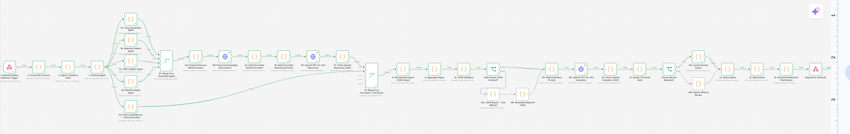

- Pinecone index
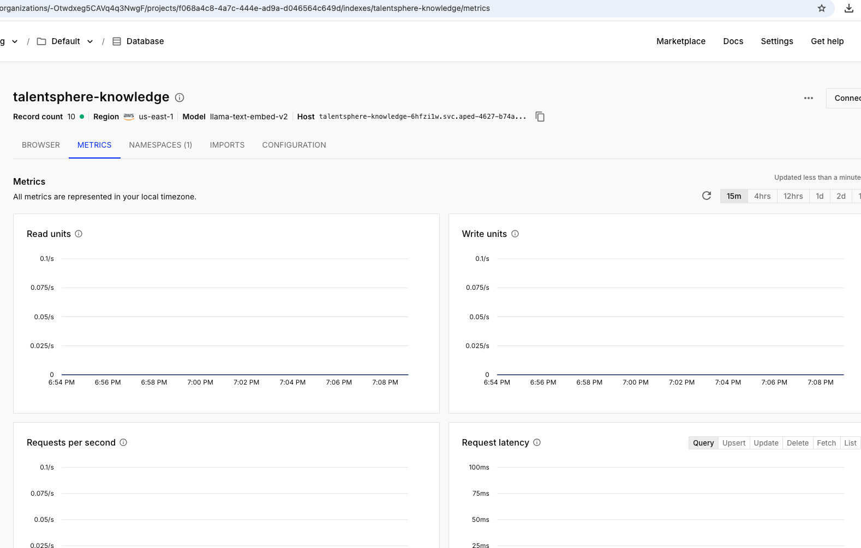

- Workflow execution
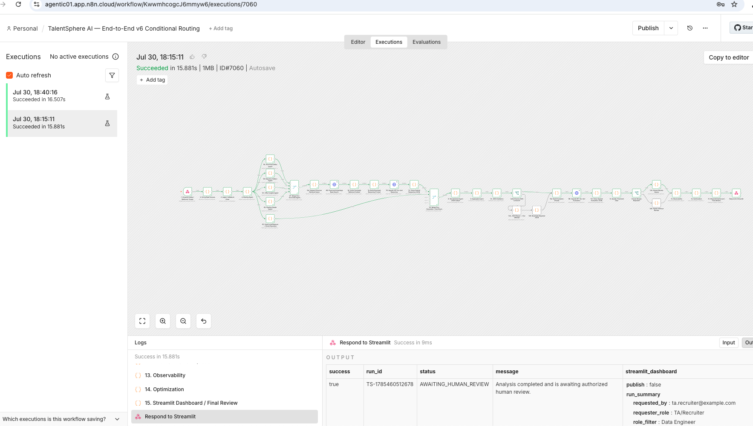
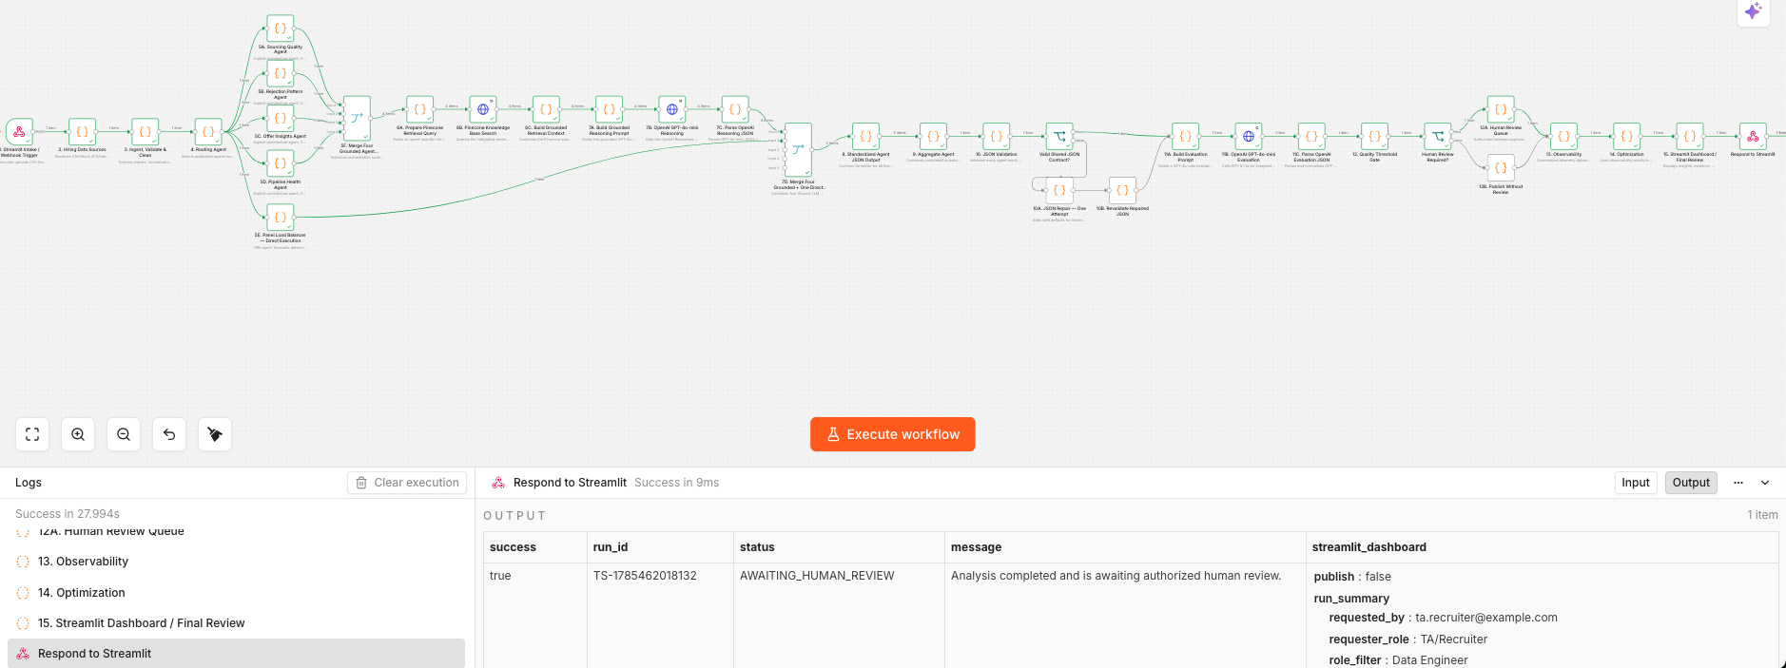
Execute http request to simulate the data load by a TA
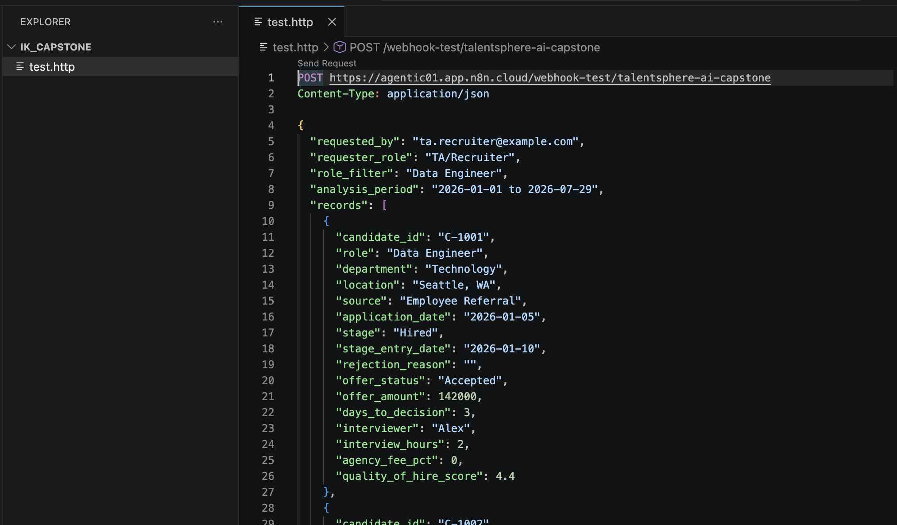
- Final output JSON

